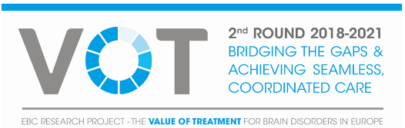 FACT SHEET CASE STUDIES RARE DISEASES
Case studies on Ataxia, Dystonia, Phenylketonuria

THE CHALLENGE
Rare neurological diseases (RNDs) like ataxia and dystonia collectively exert a public health burden in terms of their manifestations’ severity and the total number of people afflicted across their lifespan. According to the European Reference Network on neurological diseases (ERN-RND), 500.000 people are living with RNDs in Europe, 60% of those affected are still undiagnosed due to significant phenotype and genotype heterogeneity in clinical presentation and disease course. Health systems face significant challenges to respond to patients’ needs and guarantee equal access to treatment. Most rare disorders are of genetic origin. Phenylketonuria (PKU) is an inherited metabolic disorder which cause significant cognitive impairment if untreated. For many patients, considerable barriers exist in terms of access to appropriate care, delayed diagnosis, and treatment options. When patients are diagnosed, many are unable to access resources such as centres of expertise (or specialist centres), coordinated care, patient support systems, and effective treatment.
MISSION
The European Brain Council (EBC) initiated a three-year research project (results will be released in 2021) on the Value of Treatment for Brain Disorders for more equitable access to care all around Europe “Bridging the gaps and achieving seamless, coordinated care for people affected by rare diseases”. The project includes case studies on Ataxia, Dystonia and Phenylketonuria. Discussions on health care focus too often on the increase in per-person health care cost rather than on the benefits of better health. It is therefore important to emphasize the need for more value-based and patient-centred care, and the scaling-up of high-quality underpinning sustainable care models for rare diseases.
Treatment gaps—the proportion of people who require detection and treatment but do not receive these or receive inadequate care—pose the biggest barriers to improved diagnosis, treatment and care across Europe. Effective interventions exist. Strategies of early diagnosis and treatment to ensure adequate care, which are proving to be cost effective in the long run, are key. The study’s research framework includes the development of a series of qualitative and quantitative benchmarks to identify treatment gaps and causal factors along the continuum of care in a patient care pathway analysis (in alignment with the EC RarERNPath approach). The study is also assessing the socioeconomic impact and health gains from optimal health-care interventions with an economic evaluation and final evidence-based policy recommendations. Case studies are analysed in collaboration with experts from the European Brain Council’s scientific societies in line with the research framework, applying empirical evidence from different European countries.

PLANNING AND END DATE :
December 2021
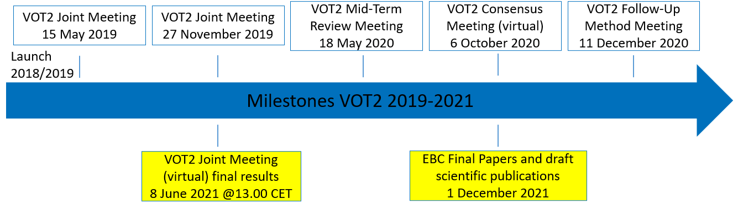

FUNDERS :
Industry partners (Biomarin, Ipsen, Reata, Takeda)

See also VOT2 Poster.
Contact person : vinc@braincouncil.eu

VOT2 Case Study on Ataxia

Aim of the Ataxia study is to understand differences in care between specialist ataxia centres compared with non specialist care for progressive ataxia in adults.

Box 1: Ataxia in a word
Ataxia is a heterogeneous group of chronic rare neurological disorders, characterized by a lack of muscle coordination which may affect speech, eye movements, the ability to swallow, walking, and other voluntary movements. Amongst the different types of progressive ataxias in Europe, the most common are inherited Friedreich’s ataxia and cerebellar ataxia. Diagnosis has generally been a long process because of the complexity of the different ataxias. The management of these conditions is also challenging and requires clinical expertise and evidence-based practice. Although there are no disease modifying treatments for the majority of progressive ataxias, there are many aspects of the conditions that are treatable, therefore the importance of guidelines to improve diagnosis and management of the ataxias [“Management of the ataxias towards best clinical practice”, third edition July 2016, Ataxia UK]. Early intervention in both the diagnosis and in management of patients with the ataxia is critical in slowing progression of disability and maintaining functional ability.

STUDY OBJECTIVES
Ataxia patients require complex care by a multidisciplinary team (MDT), including appointments with numerous health care professionals such as neurologists, general practitioners (GP) and physiotherapists. Specialist ataxia centres (SAC) can provide the necessary coordinated care and therefore address the specific needs of ataxia patients. The aim of the study, survey and analyses are to gain an understanding of ataxia patient care in the UK and other European countries. Of particular interest are any potential differences in the patient experience between patients who have attended a Specialist Ataxia Centre and those who have not.

METHOD AND EXPECTED RESULTS
- Patient care pathway and treatment gaps/unmet needs analysis of individuals with progressive ataxia: survey population from 16+ years old including statistical analysis
- Cost consequences analysis
- Sites : specialist Ataxia centres (UK, Germany, Italy)

VOT2 Case Study on Dystonia

Aim of the Dystonia study is to examine how different training levels and structured, accredited postgraduate, or sub-specializing movement Disorders (MD) training is related to dystonia diagnosis, treatment and improvement of the QoL. It will also look at the potential benefits of coordinated care combining effective team care and patient-centred planning.

Box 2 : Dystonia in a word
Dystonia is a neurological movement disorder syndrome in which sustained or repetitive muscle contractions result in twisting and repetitive movements or abnormal fixed postures. Dystonia is often intensified or exacerbated by physical activity, and symptoms may progress into adjacent muscles. Dystonia is a very complex, highly variable neurological movement disorder characterized by involuntary muscle contractions. Although an underdiagnosed condition, with an estimated prevalence rate in Europe of 15.2/100 000 for primary dystonia and 11.7/100 000 for focal forms, dystonia syndrome is the third most common movement disorder behind essential tremor and Parkinson’s disease. The disorder may be hereditary or caused by other factors such as birth-related or other physical trauma, infection, poisoning (e.g., lead poisoning) or reaction to pharmaceutical drugs, particularly neuroleptics. Treatment must be highly customized to the needs of the individual and may include oral medications, chemodenervation botulinum neurotoxin injections, physical therapy, or other supportive therapies, and surgical procedures such as deep brain stimulation.

STUDY OBJECTIVES
What are the new research developments in early intervention to improve (primary and secondary) prevention and treatment of dystonia, knowing that, as of today, there is no cure? The study will look at potential benefits of integrated, coordinated care combining effective team care and patient-centred care planning and how different training levels and structured, accredited postgraduate, or sub-specializing movement disorders (MD) training is related to dystonia treatment and improvement of the quality of life.

METHOD AND EXPECTED RESULTS
- Patient care pathway and treatment gaps/unmet needs analysis of individuals with dystonia : survey population including statistical analysis
- Cost consequences analysis
- Sites : specialist Dystonia centres (Croatia, Germany, Italy, UK)

VOT2 Case Study on Phenylketonuria
Aim of the Phenylketonuria (PKU) study is to identify the care pathways for patients accessing PKU services, and how these vary by provider and country and to evaluate the quality of life and care-related costs per patient associated with PKU, and how these vary by patient characteristics, provider and country.

Box 3 : Phenylketonuria (PKU) in a word
PKU is a rare genetic disorder, under the umbrella of inborn errors of metabolism, a disorder in which the body is not able to break down a type of protein called phenylalanine (Phe). [Phenylalanine is one of the amino acids that help in protein formation in the body. However, in PKU as the body is unable to process this amino acid, it begins to build up in the body and be harmful]. This leads to improper digestion of proteins and accumulation of phenylalanine in the body and can further affect the brain. Prevalence varies considerably across Europe –around 1/10,000 live births on average. Lifelong impact. PKU is diagnosed as a result of newborn screening. If left untreated, the increased concentration of Phe in blood and brain can lead to neurocognitive deficits – e.g. severe intellectual disability, epilepsy and behavioral problems. Therefore, guidelines are important to improve diagnosis and management of PKU [“Key European guidelines for the diagnosis and management of patients with phenylketonuria” – The Lancet/diabetes-endocrinology – September 2017]. Treatment consists of dietary restriction of phenylalanine and early intervention is key.

STUDY OBJECTIVES
Identify challenges in delivering care to patients with PKU, including access to monitoring services and provision of support to achieve optimal outcome (using Phe level as a surrogate).

METHOD AND EXPECTED RESULTS
- Patient care pathway and treatment gaps/unmet needs analysis of individuals with PKU : survey population including statistical analysis and a review of PKU Clinic structure and processes will be undertaken
- Cost-consequences analysis
- Sites : Metabolic Units (Ireland, UK, Spain)

