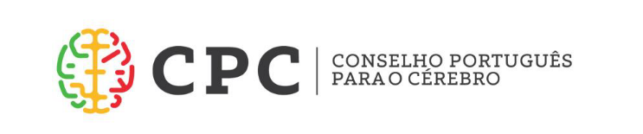

4th Academy Meeting of National Brain Councils
17th – 18th April 2018
Champalimaud Foundation, Avenida Brasília, Lisbon

Wednesday 17th April
Morning: arrival to Lisbon
13.00 Informal welcome lunch in the Champalimaud Foundation
14.00 – 18.00 NBCs Academy 1st session
14.00 Setting the scene and progress update, including European Brain Research Area project application
Frédéric Destrebecq, EBC Executive Director
14.30 National Brain Plans – case study based on the Norwegian Brain Plan launched in December 2017
Norwegian Brain Council representative, TBC
15.00 Questionnaire on the state of national brain health care
Roland Pochet, Belgian Brain Council and Polish BC representative, TBC
15.30 Value of Treatment – general update, dissemination and future plans
Speaker TBD
16.00 Coffee break
16.20 Discussion - proposed topics include:
- elections of NBC delegates to the EBC Board
- progress updates from NBCs
- possibility of organizing regional NBCs meetings (e.g. Nordic region)
- engagement in current EU budget negotiations
17.45 Shuttle to the hotel (city centre)
19.30 Joint dinner with EFNA, with participation of
Portuguese Research Ministry Representative, TBD, venue TBC


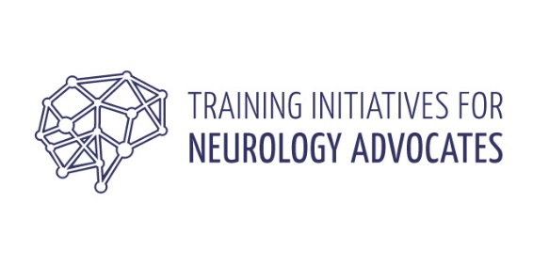

Wednesday 18th April
09.00 Shuttles depart hotel
9.30 EFNA/EBC Joint Session: The Future of Health Technology Assessment in Europe
Moderated by: John Bowis, former MEP and UK Health Minister and EBC Honorary Member
9.30 Opening remarks:
Representative from Portuguese Health Ministry, TBD
9.50 Current HTA methodological framework
Question: What are the strengths and weaknesses?
Dr. Chalon Patrice, EUnetHTA TBC
  - EU cooperation on Health Technology Assessment
Question: Is it possible, needed, desired?
Flora Giorgio, Head of Sector HTA, DG SANTE, European Commission, TBC
  - Value of Treatment for Brain Disorders
Question: How do we foster a new paradigm in value based, innovative patient centred healthcare?
Speaker TBC
11.20 Coffee break
11.40 Discussion – including discussants from Portuguese regulators: INFARMED and ACSS
12.30 Tour of the Champalimaud Foundation, followed by lunch and departure

