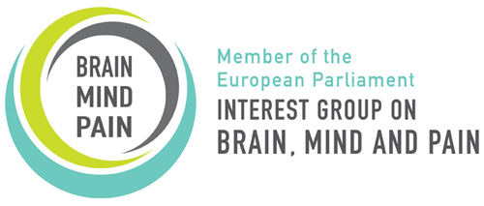

Neurological and Chronic Pain Disorders at Work
24 February 2016 8.15 -10.00h
European Parliament, Brussels

8.00* Arrivals External guest assemble at the European Parliament, meeting point TBC*
8.15 Escort to the salon where breakfast will be served
8.30 Opening address MEP co-chair Jeroen Lenaers
8.40 Further results of the EFNA Patient Experience Survey on the workplace Prof. Matilde Leonardi, Besta Neurological Institute, Italy
8.50 Rehabilitation: Prof. dr. M.F. Michiel Reneman; Fit for Work Netherlands
9.00 What’s are the solutions? Employers’ perspective Pfizer TBC
9.10 Guest speaker – Official Representative of Dutch Presidency TBC
9.20 Call to Action –Jeroen Lenaers MEP, Marian Harkin and Daciana Sarbu – presentation of Written Declaration
9.45 Q&A Session - all
10.00 Close meeting tour of the European Parliament for external guests courtesy of Jeroen Lenaers MEP

*In case of difficulties telephone Heather Clarke 0032 486 688 134

